PG Management SaaS
System Architecture Document
Version 1.0
Technology baseline
Next.js modular monolith | Vercel | AWS RDS MySQL | Prisma | AWS S3 | Resend | Vercel Cron
Environments: Local + Production
Scope: V1 architecture for the multi-tenant PG management SaaS serving Owners/Admins, Managers/Wardens, Residents, and Platform Administration.

1. Purpose and Scope
This document defines the V1 system architecture for the PG Management SaaS. It converts the approved product requirements, database model, and API contract into an implementation architecture that can guide development, deployment, security, operations, and future scaling.
- The product is a multi-tenant SaaS where one organization can own multiple PG properties.
- The application is delivered as a modular monolith in a single Next.js codebase and deployment unit.
- MySQL on AWS RDS is the system of record; AWS S3 stores private files and immutable receipt artifacts.
- The architecture prioritizes tenant isolation, financial consistency, auditability, and operational simplicity over premature microservices.
- Only two environments are planned for V1: Local and Production.

2. Architecture Goals and Non-Goals
Goals | Non-Goals
Simple deployment and debugging with one modular monolith. | Microservices, Kafka, RabbitMQ, service mesh, or distributed transactions in V1.
Strong tenant isolation and PG-scoped manager authorization. | Per-tenant databases or per-PG deployments.
Reliable billing, payment, reversal, deposit, and settlement workflows. | Full accounting/GST ERP behavior.
Mobile-friendly browser experience for residents and operations staff. | Native mobile applications in V1.
Clean module boundaries so future extraction is possible. | Premature service extraction without an actual scaling or ownership need.
Private, controlled KYC and document access. | Public S3 object exposure.

3. Locked Architecture Decisions
Decision Area | V1 Decision
Application architecture | Modular monolith
Frontend + backend | Next.js, App Router, deployed on Vercel
Primary database | MySQL
Production database hosting | AWS RDS MySQL
ORM/data access | Prisma behind repository/service boundaries
Object storage | Private AWS S3
Transactional email | Resend abstraction
Scheduled jobs | Vercel Cron calling internal authenticated job handlers
Authentication | Email + password, same mechanism for Owner, Manager, Resident
Authorization | Organization membership + role + manager PG assignments
Tenant data model | Shared database/shared schema with organization_id on tenant-owned rows
Money representation | BIGINT paise; no floating-point money
File delivery | Presigned upload/download after authorization
Billing | Draft created 5 days before due date; Manager finalizes
Payments | Manager-recorded V1 payments; corrections use reversals
Receipts | Generated PDF snapshot stored in S3
Deletion | Soft-delete/archive core entities; preserve history
Environments | Local and Production only

4. System Context
All end users access the SaaS through the browser. The Next.js application is the single business application boundary and coordinates database access, object storage, email delivery, scheduled tasks, and PDF generation.
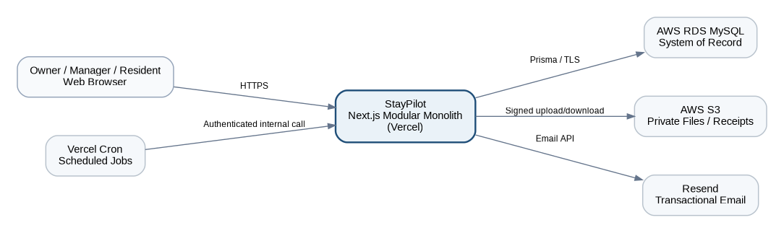
Figure 1. V1 system context and external dependencies.

5. Modular Monolith Runtime Layers
Layer | Responsibilities | Must Not Do
Presentation | Next.js pages, layouts, Route Handlers, Server Actions, input parsing, response formatting. | Contain complex financial or lifecycle business rules.
Application | Use-case orchestration such as MoveInResident, FinalizeInvoice, RecordPayment, TransferResident. | Reach directly into unrelated module tables without a defined service/repository contract.
Domain | Business rules, invariants, calculations, state transitions, policy validation. | Depend on React, HTTP, Vercel, Prisma, S3, or Resend.
Infrastructure | Prisma repositories, MySQL, S3 adapter, Resend adapter, PDF renderer, logging, cron integration. | Own business decisions that should live in domain/application layers.
UI / HTTP
-> Application Use Case
-> Domain Rules / Module Services
-> Repository / Infrastructure
-> MySQL / S3 / Resend

6. Module Boundaries and Ownership
The monolith is organized by business capability. Module boundaries are code-organization and ownership boundaries, not network services. Cross-module writes should be coordinated by application use cases rather than direct table manipulation.
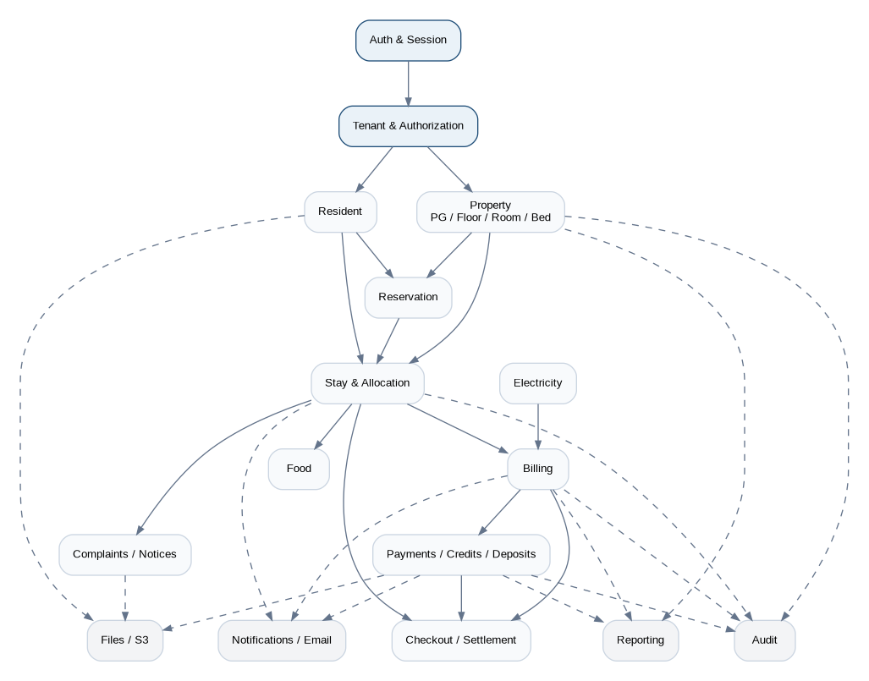
Figure 2. Logical module dependency map.
Module | Owns / Responsible For
Auth & Session | Credentials, password reset, invitation activation, login/session lifecycle.
Tenant & Authorization | Organizations, memberships, roles, manager-to-PG assignment checks, ActorContext.
Property | PGs, floors, room types, rooms, beds, operational availability.
Resident | Organization-specific resident profile, KYC metadata, document associations.
Reservation | Reservation lifecycle and overlap validation before move-in.
Stay & Allocation | ResidentStay, room/bed allocation history, room transfer, PG transfer boundaries.
Billing | Rent rates, services, invoice drafts, invoice items, proration, finalization.
Payments | Payments, allocations, reversals, credits, deposits, receipts.
Electricity | Meters, readings, room/floor/manual calculation and resident allocation.
Checkout | Notice period, lock-in enforcement/warnings, final settlement, bed release.
Food | Menus, meal types, polls and resident votes.
Complaints & Notices | Resident complaints, status changes, notices and targeting.
Files | S3 metadata and signed access.
Notifications / Email | In-app notifications and transactional email delivery.
Audit | Append-only audit events for important business changes.
Reporting | Read-oriented dashboards and reports over tenant-scoped data.
Platform Admin | Manual organization onboarding, demo tenant, tenant status, support functions.

7. Recommended Codebase Structure
src/
app/ # Next.js routes, pages, layouts
modules/
auth/
tenant/
property/
resident/
reservation/
stay/
billing/
payments/
electricity/
checkout/
food/
complaints/
notices/
notifications/
files/
audit/
reporting/
platform-admin/
shared/
db/ # Prisma client / transaction helpers
errors/
validation/
security/
logging/
money/
dates/
idempotency/
config/
Rule: Route Handlers and Server Actions remain thin. Business behavior belongs in module/application services, not directly in React components or transport handlers.

8. Request Processing Flow
- Browser sends HTTPS request to the Next.js application.
- Transport layer parses the request and resolves the authenticated session.
- Tenant middleware/service builds ActorContext with user ID, organization ID, roles, and allowed PG IDs.
- Input is validated using the application validation layer.
- Application use case checks authorization and executes domain rules.
- Repository methods issue tenant-scoped Prisma/MySQL queries.
- Audit/notification/internal-event side effects are triggered only after the business operation is valid.
- Transport returns the standardized API response and request correlation ID.
ActorContext {
userId
organizationId
roles[]
allowedPgIds[]
residentId?
}

9. Authentication, Identity, and Tenant Authorization
Authentication identity is global, while business data is organization-specific. The same email can represent one global login identity across multiple organizations without revealing any organization-specific resident history to another tenant.
Concern | Architecture Rule
Login ID | users.email is globally unique for authentication.
Business resident profile | Separate resident row per organization; tenant records never become globally visible.
Owner/Manager/Resident login | Same email/password login page; role selection is not requested from the user.
Resident invitation | Resident record may exist before login; global User/membership is linked/created when move-in is confirmed.
Manager scope | Manager may be assigned to multiple PGs; every PG-scoped operation validates assignment.
Multiple owners | An organization may have multiple OWNER memberships.
Platform Admin | Separate privileged platform role; no automatic visibility into tenant KYC by default.
Session | Use secure HttpOnly cookie/session mechanism from the chosen mature Next.js-compatible auth library.
Password handling | Passwords are hashed with a modern slow password algorithm and never emailed. Invitation email contains a single-use password-set link.
Implementation flexibility: The exact auth library is intentionally not locked in this architecture document. It must support secure email/password sessions, invitation/reset flows, and server-side authorization in Next.js.

10. Multi-Tenancy and Data Isolation
- V1 uses a shared MySQL database and shared schema, not a database per organization.
- Every tenant-owned table includes organization_id. PG operational records additionally include pg_id where relevant.
- Repositories accept tenant context explicitly; avoid generic findById(id) for tenant-owned data.
- Related IDs supplied by a client are revalidated to belong to the same organization and permitted PG scope.
- Resident self-service endpoints should prefer /me semantics rather than accepting arbitrary resident IDs.
- File signing, report generation, and audit access are tenant-authorized before data or signed URLs are created.
Preferred repository signature:
findStay({ organizationId, stayPublicId })
Avoid:
findStay(stayId)

11. Persistence Architecture - MySQL and Prisma
MySQL is the authoritative source for tenant structure, occupancy history, billing, payments, deposits, electricity, complaints, audit metadata, and workflow state. Prisma is the primary application data-access layer, but domain/application services remain independent from direct ORM usage.
- Use InnoDB and foreign keys for relational integrity.
- Use BIGINT internal primary keys and stable public UUIDs for externally exposed resource IDs.
- Store currency as BIGINT paise. Format as INR only at presentation boundaries.
- Store timestamps in UTC. PG timezone drives billing-date/day calculations.
- Use indexed organization_id / pg_id / status / date columns based on access paths documented in the database design.
- Avoid database writes directly from React components or arbitrary utility code.

12. Transaction Boundaries and Consistency
Operations that change several business records must be atomic inside a MySQL transaction. External services such as S3 and Resend cannot participate in a MySQL transaction, so they are handled after commit with idempotent/retry-safe behavior.
Use Case | Transaction Scope
Reservation | Validate overlap -> create reservation -> record deposit linkage/history -> audit metadata.
Move-In | Validate bed/reservation -> create stay -> allocation -> rent/services/deposit state -> close reservation -> audit.
Room Transfer | Close old allocation -> create new allocation -> rent/proration state -> audit.
PG Transfer | Close old stay -> create new stay -> optional same-organization deposit transfer -> allocations -> audit.
Invoice Finalization | Validate DRAFT -> lock totals/items -> status transition -> audit.
Record Payment | Payment -> allocations -> invoice statuses -> credit entry if needed -> receipt snapshot metadata -> audit.
Payment Reversal | Reversal -> reverse allocations/credit effect -> recompute invoice statuses -> audit.
Checkout | Final invoice state -> deposit settlement -> close stay -> close allocation -> release bed -> audit.
External side effects: PDF creation, S3 upload, and email delivery occur after the database commit. Their handlers must be safely retryable so a transient external failure does not corrupt the financial transaction.

13. Concurrency and Race-Condition Controls
- Bed reservation and move-in availability must be checked inside the same transaction used to create the reservation/allocation.
- Two concurrent managers attempting to reserve/occupy the same bed must result in one success and one 409 Conflict.
- Critical commands use unique constraints and/or row locking where appropriate; frontend availability checks are informational only.
- Billing draft generation has a unique business key (stay + billing period + invoice type) so duplicate cron executions do not create duplicate invoices.
- Payment commands accept an idempotency key to protect against accidental resubmission where the API design specifies it.

14. Critical Workflow - Reservation to Move-In
Figure 3. Move-in orchestration and transaction boundary.
The resident login account is activated only after move-in. Reservation does not start rent. Move-in is the event that creates the active stay, allocation, rent cycle, and resident invitation.

15. Billing Architecture
Figure 4. Automatic draft billing and manager-controlled finalization.
- A daily scheduled job identifies active stays whose billing due date is five days away.
- The job calculates base rent, enabled recurring services, eligible electricity charges, and configured adjustments to create a DRAFT invoice.
- Managers review and may correct draft values. Overrides require a reason and are audited.
- Only Manager-controlled finalization moves the invoice to FINALIZED. V1 does not auto-finalize on due date.
- Previous outstanding amounts remain on their original invoices; the UI may aggregate them but must not duplicate them as new invoice items.
- Finalized financial data is changed through adjustment/reversal workflows, not silent edits.

16. Payment, Credit, Deposit, and Receipt Architecture
Component | Rule
Payment | Recorded against a resident/stay with an explicit financial purpose and payment mode.
Payment Allocation | One payment may allocate to multiple outstanding invoices; default recommendation is oldest outstanding first, manager may adjust before save.
Overpayment | Unallocated amount becomes resident/stay credit via a credit ledger, not a mutable balance-only field.
Security Deposit | Tracked against the stay using deposit transactions; partial receipts are supported.
Same-organization PG transfer | Deposit may move using explicit TRANSFER_OUT / TRANSFER_IN entries.
Cross-organization change | Previous organization settles independently; new organization starts fresh.
Correction | Finalized payments are not edited/deleted. Create reversal then, if needed, a corrected payment.
Receipt | Persist receipt snapshot data, generate PDF, upload to S3, and store object key; old receipts do not change when PG/resident data later changes.

17. File and Document Storage Architecture
Files are stored in private S3 buckets/prefixes. MySQL stores metadata and relationships, not binary file contents. The application authorizes every upload/download and issues short-lived presigned URLs.
Browser -> POST request for upload intent
Next.js -> authenticate + authorize + validate file category
Next.js -> create short-lived presigned S3 upload URL
Browser -> upload directly to S3
Browser/Next.js -> confirm metadata / attach file to domain entity
- KYC, payment proofs, complaint images, profile images, PG images, and receipt PDFs use different logical categories/prefixes.
- Do not permanently store public S3 URLs; store bucket/object key and metadata.
- Resident document replacements create versions; verification state is stored separately from the physical file version.
- KYC retention is configurable per PG. Default is to keep history; stay/financial history remains even if a KYC file is later purged.

18. Notifications and Transactional Email
Channel | Purpose
In-app notifications | Rent reminders, invoice/bill events, complaint updates, notices, transfer/checkout updates.
Resend transactional email | Owner/manager/resident invitations, password reset, receipt delivery, selected system communications.
Internal events | In-process events decouple side effects such as audit, receipt generation, and notifications from core use-case logic.
PaymentRecorded
-> AuditHandler
-> ReceiptGenerationHandler
-> NotificationHandler
-> Optional ReceiptEmailHandler
Abstraction: Business modules call an EmailService interface rather than Resend directly so the provider can be replaced later without rewriting domain logic.

19. Scheduled Jobs and Background Work
Job | Frequency / Trigger | Behavior
Billing Draft Job | Daily | Creates missing draft invoices for eligible stays five days before due date.
Rent Reminder Job | Daily | Creates resident/manager reminder notifications based on due dates and finalized/draft state.
Upcoming Checkout Job | Daily | Surfaces notice/checkout tasks and reminders.
KYC Retention Job | Daily or low-frequency | Purges eligible files only when tenant retention policy permits.
Notification/Email Retry | On demand / scheduled sweep | Retries recoverable external delivery failures without duplicating business records.
- Cron endpoints are internal and authenticated; they are not public business APIs.
- Jobs record execution status, processed counts, failures, and correlation IDs for operations visibility.
- Jobs are idempotent. Re-running a job must not duplicate invoices, reminders, or retention actions.

20. Environments and Deployment Architecture
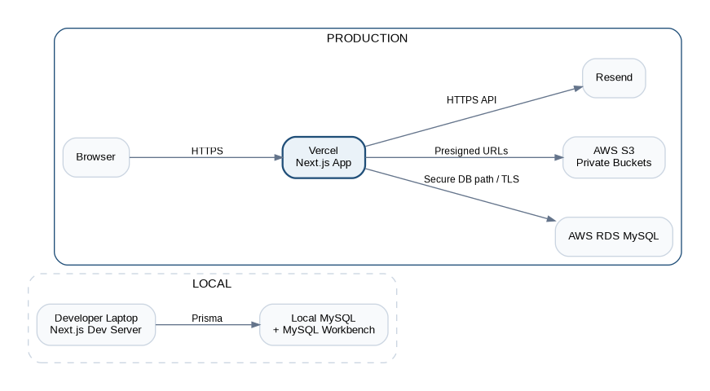
Figure 5. Local and Production environment topology.
Environment | Application | Database | Files / Email
Local | Next.js dev server on developer machine. | .env.local points to local MySQL; MySQL Workbench is a developer GUI/tool. | Use dedicated development/test S3 prefix or bucket and Resend development/test configuration.
Production | Next.js deployed on Vercel. | AWS RDS MySQL; production-only credentials and schema migrations. | Production private S3 bucket/prefix and production Resend configuration.
No staging in V1: Feature testing happens locally before production deployment. This keeps infrastructure simple, but production changes require disciplined migration, rollback, and release practices.

21. Production Database Connectivity and Connection Management
The production application runs on Vercel while MySQL runs on AWS RDS. The database must not be broadly exposed. Production implementation must use a secure connectivity pattern that restricts database ingress and enforces TLS.
- Never configure RDS/MySQL port 3306 as open to 0.0.0.0/0.
- Use a controlled outbound/allowlist or proxy/connectivity pattern appropriate to the selected Vercel plan and AWS design.
- Use pooled/managed Prisma connections and avoid creating a brand-new unmanaged database connection per request.
- Set conservative database connection limits and validate behavior under concurrent Vercel function execution.
- All production database credentials are stored as protected environment secrets, never in source control.
Implementation checkpoint: The exact Vercel-to-RDS network mechanism is intentionally an infrastructure implementation choice. It must be finalized before production launch and documented in the deployment runbook.

22. Configuration and Secrets
Configuration Type | Examples | Handling
Public app config | Application name, non-sensitive UI feature flags. | Safe to expose only when intentionally public.
Database secrets | RDS host/user/password/connection URL. | Protected Vercel environment secrets; never committed.
AWS secrets | S3 credentials or role/configuration. | Least privilege; rotate; production only where required.
Resend secret | API key and sender configuration. | Protected environment secret.
Auth secrets | Session signing/encryption/reset/invitation secrets. | High-entropy protected secrets; rotate using documented process.
Cron secret | Internal job endpoint authorization secret. | Protected secret validated on every scheduled invocation.

23. Security Architecture
- HTTPS only in production; secure HttpOnly cookies for authenticated sessions.
- Authorization is server-side and independent of what the UI shows or hides.
- Tenant and PG scope is validated before returning data, generating signed URLs, or performing mutations.
- Use input/schema validation at all API boundaries and parameterized ORM queries.
- KYC objects are private; normal lists show verification status and masked identifiers instead of exposing full values.
- Financial operations require explicit permissions, transactional integrity, and append-only audit history.
- Destructive and financial corrections require confirmation and, where appropriate, a reason.
- Use rate limiting / abuse controls on login, reset-password, invitation, and sensitive public endpoints as needed.
- Platform Admin does not automatically receive unrestricted access to tenant KYC content.

24. Error Handling and Domain Failure Model
Error Type | Typical HTTP | Example
ValidationError | 400 | Malformed date, invalid amount, missing required field.
AuthenticationError | 401 | No valid session.
AuthorizationError | 403 | Manager is not assigned to requested PG.
NotFoundError | 404 | Resident/room/invoice not found in current tenant.
ConflictError | 409 | Bed became unavailable, duplicate invoice period, duplicate active reservation.
BusinessRuleError | 422 or 409 | Invalid lifecycle transition, finalized invoice cannot be edited directly.
InfrastructureError | 500/503 | Temporary database, S3, or email-provider failure.
- Transport layer maps domain/application errors to standardized API error responses.
- Unexpected failures receive a correlation/request ID that is also written to logs.
- Sensitive internal details, SQL, secrets, and stack traces are never returned to end users.

25. Observability and Auditability
Signal | Purpose
Application logs | Request lifecycle, domain operation summaries, integration failures, correlation IDs.
Error tracking | Unhandled exceptions and production regressions.
Cron/job logs | Execution start/end, processed counts, skipped counts, failures.
AWS RDS monitoring/logs | Database load, connections, slow/error conditions.
Audit logs | Who changed important business/financial state, previous/new values, reason.
Email delivery metadata | Delivery attempt/result without exposing passwords or sensitive KYC data.
Operational requirement: If automatic billing fails, operators must be able to determine whether the job ran, which stays were processed, which invoices were created/skipped, and why any item failed.

26. Performance and Scaling Strategy
- Start with server-rendered/server-driven Next.js pages and paginated APIs; optimize only measured hotspots.
- Use appropriate MySQL indexes for organization/PG/status/date access patterns; avoid unbounded list queries.
- Read-heavy dashboard/report queries may use dedicated query services and carefully optimized SQL when Prisma abstraction becomes inefficient.
- Large files upload directly from browser to S3 via presigned URLs rather than through the Next.js runtime.
- Do not add Redis in V1. Add caching/queue infrastructure only when actual workload demonstrates the need.
- Modules are structured so a capability such as billing or notifications can be extracted later if independent scaling or ownership becomes necessary.
Scaling Trigger | Potential Evolution
High read/report load | Read replicas, precomputed aggregates, reporting-specific read model.
High background-job volume | Introduce managed queue/worker architecture.
High notification volume | Dedicated async notification worker/provider queue.
Independent billing scale/team | Extract Billing module behind stable API/events.
Global user base | Regional deployment/CDN optimization and explicit data-residency strategy.
High DB connection pressure | Managed database proxy/pooling/connectivity improvement.

27. Failure Handling and Resilience
Failure | Expected Behavior
Resend unavailable | Core business transaction may still commit; email status is retryable and visible to operations.
S3 upload fails before metadata confirmation | No domain record should claim a successful file attachment until confirmation succeeds.
Receipt PDF generation fails after payment commit | Payment remains valid; receipt generation is retryable using immutable snapshot data.
Billing cron executes twice | Unique business key/idempotency prevents duplicate draft invoices.
MySQL transaction fails | Rollback all changes inside the transaction and return a safe error.
Manager double-submits payment | Idempotency key/transaction rules prevent duplicate money recording.
Concurrent bed allocation | One transaction wins; the other returns conflict and refreshes availability.

28. Backup and Recovery Principles
- Enable production RDS automated backups and point-in-time recovery appropriate to the selected AWS plan/configuration.
- Use S3 durability/versioning/lifecycle controls as appropriate for production file-retention requirements.
- Database migrations are version-controlled and reversible/repairable through documented deployment procedures.
- Critical financial history is not hard-deleted as part of normal application workflows.
- Recovery procedures should prioritize database integrity first, then S3 artifact reconciliation and email/notification replay where necessary.

29. Data Retention, Soft Deletion, and Privacy Boundaries
Data | Default Behavior
User account | May be disabled/deactivated; authentication access can be revoked.
Resident/Stay history | Preserved for operational/financial history within the organization.
Payments/Reversals/Receipts | Preserved; financial history is never silently rewritten.
Rooms/Floors/PGs | Archive/inactivate rather than hard-delete when historical references exist.
KYC files | Configurable retention; default keep history. Purging the file does not erase stay/financial history.
Audit logs | Append-only and retained according to product/organization policy.

30. Release and Migration Approach
- Local development uses local MySQL. Schema changes are created through Prisma migrations and reviewed in source control.
- Production database migrations are applied as an explicit release step before/with the compatible application release.
- Backward-compatible expand/migrate/contract techniques should be used for risky schema changes because there is no staging environment in V1.
- Production configuration/secrets are maintained separately from Local configuration.
- Deployments should include a documented rollback decision path for application code and a migration repair/forward-fix path for database changes.

31. Non-Functional Architecture Requirements
Area | Requirement
Security | Tenant-isolated authorization, private files, protected sessions/secrets, auditable financial actions.
Reliability | Atomic financial/lifecycle writes; idempotent scheduled and critical commands.
Performance | Paginated operational lists, indexed tenant queries, direct S3 uploads, efficient dashboard queries.
Scalability | Support many organizations/PGs/residents in shared schema; modular boundaries permit later extraction.
Maintainability | Business modules, thin transports, repository boundaries, centralized error/validation/security helpers.
Usability | Responsive Next.js UI with mobile-first resident experience and operationally efficient manager workflows.
Auditability | Immutable financial correction history and append-only audit records for important state changes.

32. Implementation Details Intentionally Left Flexible
Topic | Current Architecture Position
Auth library | Use a mature Next.js-compatible email/password/session library; exact package chosen during implementation.
Vercel -> RDS secure connectivity | Must be restrictive/TLS and production-ready; exact Vercel/AWS networking option finalized before go-live.
PDF rendering library | Must generate deterministic immutable receipt PDFs compatible with Vercel runtime or a supported generation path.
Rate-limiting implementation | Introduce at public/auth sensitive boundaries using a Vercel-compatible mechanism when implementation begins.
Advanced caching/Redis | Not required for V1; only add based on measured performance/coordination need.

33. Architectural Invariants
1. Business modules do not trust tenant, role, or PG scope supplied by the browser.
2. Resident identity is separated from ResidentStay and bed allocation history.
3. PG-to-PG transfer creates a new stay; room/bed transfer inside a PG creates a new allocation record.
4. Money is represented in integer paise and finalized financial records are not silently edited.
5. KYC files are private and access-controlled; database stores metadata, not binary files.
6. Core lifecycle and financial multi-write operations execute in MySQL transactions.
7. External side effects are retryable and cannot retroactively corrupt a committed financial transaction.
8. Scheduled jobs and retried commands are idempotent.
9. Soft deletion/archive preserves historical foreign-key relationships.
10. The modular monolith remains one deployable application until actual scale/ownership pressure justifies extraction.

34. Recommended Architecture Implementation Sequence
Phase | Architecture Work
1 | Next.js project foundation, module conventions, configuration, errors, validation, logging.
2 | Prisma/MySQL foundation, migrations, tenant context, Auth/session, Organization/Membership authorization.
3 | Property + Resident + Reservation + Stay/Allocation modules.
4 | S3 file service + KYC/versioning + invitation/Resend integration.
5 | Rent/services + Billing draft/finalization engine + cron/idempotency.
6 | Payments, allocations, credits, deposits, reversals, receipt snapshots/PDF.
7 | Electricity + checkout/settlement.
8 | Complaints, notices, food, notifications, reporting, audit UI.
9 | Production hardening: RDS connectivity, secrets, backups, monitoring, rate controls, recovery runbook.

35. Traceability to Product and Design Artifacts
Artifact | Relationship
Product Requirements Document v1.0 | Defines roles, resident lifecycle, billing rules, electricity, food, complaints, checkout, reports and V1 scope.
Database Design Document v1.0 | Defines the MySQL data model and constraints that implement the architecture persistence boundaries.
API Design Document v1.0 | Defines the HTTP contracts, role permissions, idempotency, request/response conventions and endpoint catalog.
System Architecture Document v1.0 | Defines runtime boundaries, module ownership, deployment, security, consistency, failure handling and scaling rules.

36. Architecture Baseline Summary
The V1 architecture deliberately favors a disciplined modular monolith over distributed systems. Next.js on Vercel provides the single application runtime; AWS RDS MySQL provides transactional consistency; AWS S3 holds private documents and immutable receipt artifacts; Resend provides transactional email; and Vercel Cron drives recurring billing/reminder jobs. Tenant isolation, financial integrity, auditability, and mobile-friendly operations are treated as first-class architectural requirements.
Baseline status: This document is the implementation architecture baseline. Future changes should be recorded as explicit architecture decisions rather than introduced as ad-hoc cross-module dependencies.

